**Smart Gate Controller**

*Cypher*

*Date*

***Important Notes:***

* ***The descriptions in italics in this document (except for some section headings) are exemplary and explanatory and must be removed from the completed report.***
* ***Identify which section of this report was created by which team member***
* ***Your documentation should have ca. 8 pages.***

# Team members

1. Sheikh Muhammad Adib Bin Sh Abu Bakar
2. Zafirul Izzat Bin Mohamad Zaidi
3. Muhammad Farid Izwan Bin Shabri
4. Muhammad Iqbal Bin Mohd Fauzi

# Introduction

What are “Internet of Things” and “Wireless Sensors Network” in your project domain about?

For our project we plan to make a smart gate controller that mainly use for controlling people entering an area. For instance, entering gate at theme park. Our smart gate control is capable of counting people who entering and leaving an area through the gate and block people from using the gate. To make it more compatible with big area environment, this system support controlling the gate from distance. This where we use the concept of internet of thing where all the component in our system is capable to connect to internet so that the admin can control the gate even though he or she are not there. Since an area could have many gates, we will group all the sensor and actuator for a gate and connecting them to a node. This where we apply wireless sensors network concept to concept all the node with a master controller.

___________________________________________________________________________

Over the last decade, an increasing number of "things" have been linked to the internet. The term "things" refers to a wide range of devices, ranging from cars with built-in sensors to heart monitoring implants or smart thermostats in private homes. In the context of this article, a "thing" throughout this project refers to a gate controller that may be controlled remotely by the user. Sensors and network connectivity enable these items to examine their surroundings, report their condition and location, receive instructions, and even carry out activities based on the data they receive. The sensor used in the project to count visitors is how data is sent and received throughout our project. The phrase "Internet of Things" refers to a vast and rapidly expanding network of physical items equipped with sensors and network connection (IoT). Until recently, the Internet was thought to be a network that managed human-created and processed information. However, the Internet of Things now allows things to interact with one another, make choices, and take actions — all without the need for human participation. IoT enables new means of controlling and monitoring processes, corporations, and organizations by bringing devices and things online. The sensor technology that powers IoT is rapidly evolving, and it already ranges from simple identification tags to complicated sensors. [1]

# Concept description

*Block diagram of your target application.*

*What is the main application for your prototype??*

*Which devices, sensors, actuators, apps etc. are using for your application?*

1. *Requirement diagram*

The requirement diagram serves as the foundation for our project. In this requirement diagram, we outline all the critical components required in our system. The smart gate controller in this system can open and close the gate, allowing the visitor to enter or exit. We will use one sensor and two actuators in our smart gate controller. These two actuators are a motor that counts persons and an LED that indicates whether the gate is open or closed. The user will be able to manage the state of the gate by interacting with the server using, which in this case is a raspberry pie acting as a server. In addition, we will use Arduino Uno Wi-Fi that act as node to communicate with server and sensor.

1. *Use case diagram*

*Our next step to define the intended behavior of our system using use cases. We chose this modeling as one of our next methods since it allows us to create a system from the standpoint of the user reader. Now, in the graphic below, we will describe our use case diagram. With both of the information that we gathered from said diagrams, we have a clearer vision and better understanding of the overall system. This is important as we can now develop a more concrete system architecture with refined details. That is exactly what we did on this research paper for the reader to easily digest our overall system architecture.*

*As we can see, at the outside of the system, it consists of user, node which is act as middle man in the system and server. The user or also known as admin can have information on the number of visitors. The user also capable of send request to the server. The main thing about the user is that the user can control gate remotely. So, the gate can open and close based on the command given by the user. On the node perspective, the node can count visitor enter and leave with the help of sensor. The node can also get gate state which is either on and off. Lastly, we move to the server. For extra information, the server that we use in the implementation part is using raspberry pi. The server can store data both from user and node. Not to forget, the most important part is the data of the system itself. After get a little bit of knowledge about the overview of our system, we will move to our next approach which is activity diagram.*

1. *Activity diagram*

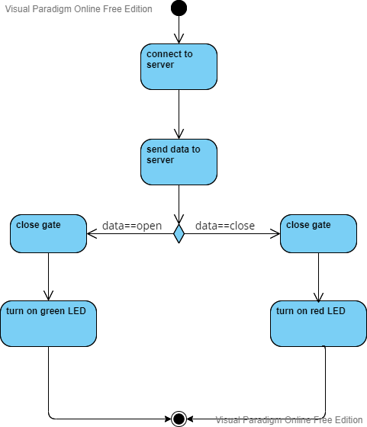

To see more details about the scenario, the activity diagram is modelled. Figure above shows how the overall scenario for Smart Gate Controller will be run. Firstly, it will connect to the server. After connecting to the server, it will send data, either the gate will open or close. If, the gate is closed, then green LED will turn on. On the other hand, if the gate is opened, red LED will pop out.

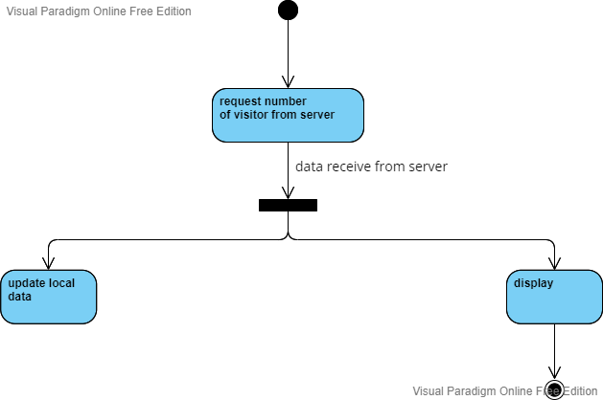

Class diagram as shown as figure above explains how user get the data about number of visitors. User will request number of visitors from server. Then, the data will be displayed and also local data will be updated once the data is received.

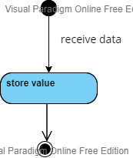

Figure above shows how data is stored. At the beginning, it will receive data, then the data that is received will be stored.

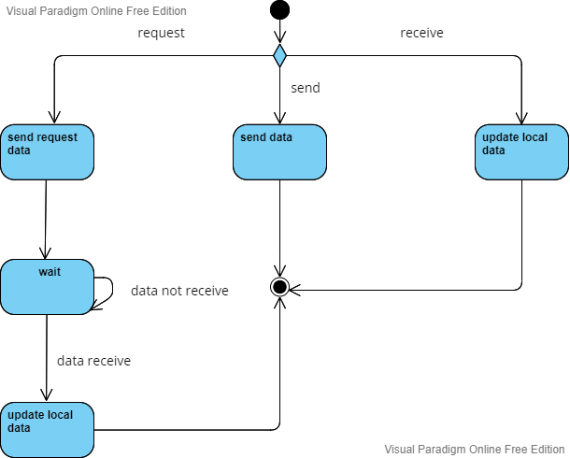

The diagram above describes how the data is transmitted. From initial node, there is a decision node either the data is requested, received or send. If the data is requested, so the required data will be sent. And then, go to wait state, if the data is not received. If requested data is received, local data will be updated. Besides that, from decision node, send data and update local data are parts of how data is transmitted.

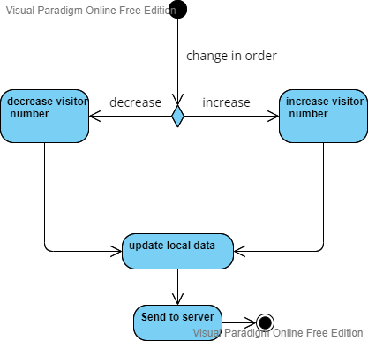

Class diagram above explains how visitor counter works. If there is change of number of visitors, if it is ether increase or decrease, the counter will count the latest number of visitors. Once the latest number is calculated, the local data will be updated then then, it will send to the server.

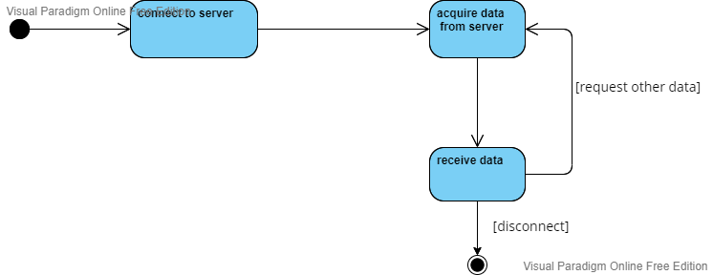

The figure above shows how the server will receive data. Initially, the server is connected. The server will request the data. The requested data then will receive by the server. Once the server is done with receiving data, it will be disconnected.

1. *System architecture*

Figure below explains the system architecture of Smart Gate Controller. It consists of User Interface, Server and Node. For each subsystem, it will define more details, what happen in every subsystems.

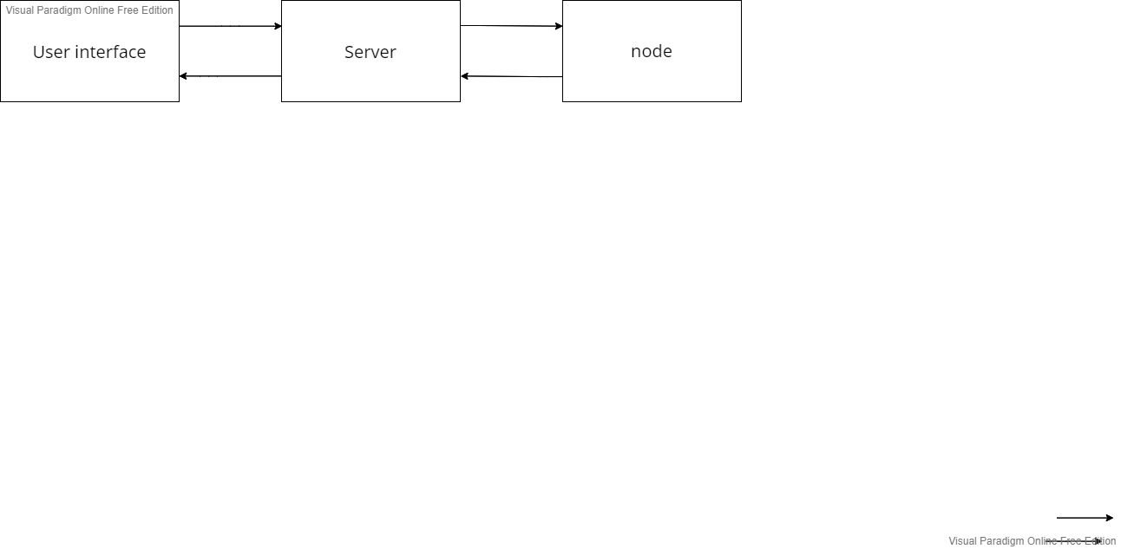

Figure below shows how the architecture of user interface looks like. For user interface subsystem, it consists of 5 main components: input interface, output interface, controller, database and communication system.

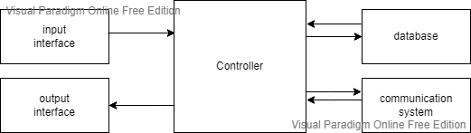

For the server subsystem, there are 3 main components play big role to make sure the server is good. The three components are communication system, data manager and database as shown in figure below.

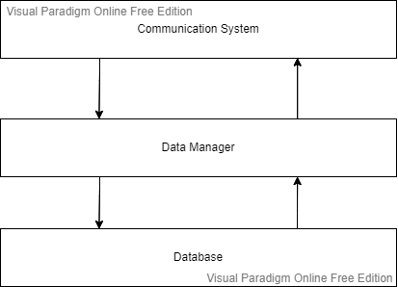

Lastly, figure below shows node subsystem. Node subsystem is made up from 5 main components, communication system, data manager, sensor, actuator and database.

For our project we will use rotary sensor to count number of people. dc motor is use to open and close gate. Last but not least is led which is act as a sign for visitor enter and leaving.

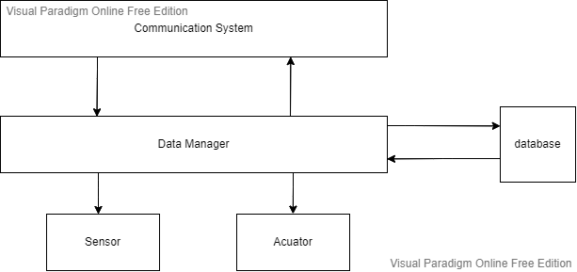

Table below shows the sensor and actuator that we will use in our project

|  |  |
| --- | --- |
| Sensors | Actuator |
| Rotary encoder | LED |
|  | Motor DC/ Lock solenoid |
|  |  |
|  |  |
|  |  |

# Project/Team management

*Which project methods you used in your project?*

*Breakdown: How you managed your tasks?*

*What are the different tasks/roles of the team members in the project?*

*Describe which team member did which tasks.*

# Technologies

# *Describe the technological approaches you will use to implement your project.*

* *Rotary encoder*
* *LED*
* *DC motor*
* *Wifi*
* *C, C++, Phyton*
* *Web base application*
* *Star topology*
* *...*

# Implementation

*Describe the static structure of the environment.*

*Provide a class diagram for this purpose and briefly explain the classes or modules.*

*Describe the use case(s) of your environment*

# Use Case

*Give instructions on how to use your application. Potentially using an/more example(s), figures, screenshots etc.*

# Sources/References

*Provide the sources on the technologies and algorithms you used in your project (Github).*

*[1]* A. S. Gillis, “What is IOT (internet of things) and how does it work? - definition from techtarget.com,” *IoT Agenda*, 04-Mar-2022. [Online]. Available: https://www.techtarget.com/iotagenda/definition/Internet-of-Things-IoT. [Accessed: 15-May-2022].

*[2]* F. Kreische, A. Ullrich, and K. Ziemann, “Introduction: The internet of things is already here,” *10innovations.alumniportal.com*, 2013. [Online]. Available: https://10innovations.alumniportal.com/internet-of-things/introduction-the-internet-of-things-is-already-here.html. [Accessed: 15-May-2022].